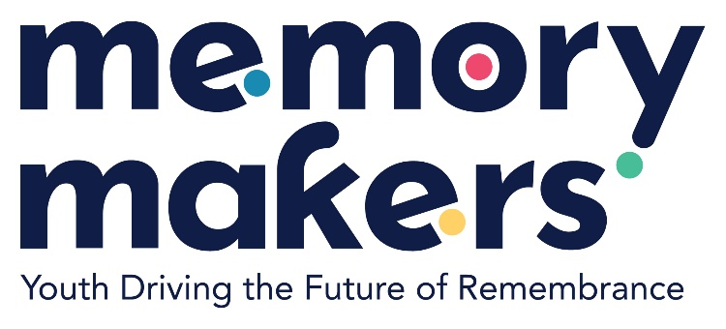

|  |  |
| --- | --- |
| **Location:** | Strasbourg/France |
| **Date(s):** | Part 1 Conference : 08 April 2025 Part 2 Conference : 26 April 2025 |

**YOUTH SYMPOSIUM  EVENT REPORT**

|  |  |  |  |
| --- | --- | --- | --- |
| Female: | 24 | | |
| Male: | 23 | | |
| Non-binary: | 4 | | |
| From country 1 France: | 17 | | |
| From country 2 Albanian: | 7 | | |
| From country 3 Italy: | 4 | | |
| Total number of participants: | 51 Participants | From total number of countries: | 15 Countries |

The *Youth Symposium on Historical Narratives and Human Rights* successfully convened over two days in partnership with Youth Group of the Conference of International Non-Governmental Organisations (INGOs) of the Council of Europe and with IGLYO Europe, aligning with **ROMA DAY** and **Europe Day**, symbolically reinforcing the connection between historical remembrance and European unity. The event gathered a focused group of 51 participants, including youth leaders, educators, historians, and human rights activists from at least five eligible countries with all members of the Conference of International Non-Governmental Organisations (INGOs) of the Council of Europe.   
  
**Objectives and Highlights:**  
The Symposium aimed to deepen understanding of historical narratives—particularly around World War II—and their influence on contemporary human rights discourse. Through keynote speeches, interactive workshops, and moderated discussions, the event encouraged critical reflection on the role of memory in shaping social justice efforts. First Conference is moderate by Ece Ciftci from the Council of the Europea and second conference is moderate by Isuf Halimi director of the ECHR and working group is moderate by the Ahmed El-Salawy IGLYO.

Key sessions included from *Youth Symposium on Historical Narratives and Human Rights:*

* A panel on “ Roma Holocaust Memorial Day” featuring historians and activists.
* A youth-led roundtable on intergenerational dialogue and combating antisemitism.
* LGBTIQ+ groups that developed mini-projects linking history education with civic engagement.

**Outcomes:**  
Participants exchanged best practices in history teaching and human rights advocacy. Youth participants notably committed to forming a cross-national network to continue collaborative initiatives. Educators reported increased motivation to integrate remembrance pedagogy in curricula. The event concluded with a symbolic commemoration of Holocaust historians activities, reinforcing the importance of historical awareness in sustaining democratic values.

**Conclusion:**  
The Symposium achieved its core aim of empowering young people and educators to use historical narratives as instruments for tolerance, dialogue, and human rights promotion. It fostered a dynamic space for intercultural learning and laid the groundwork for future transnational cooperation.