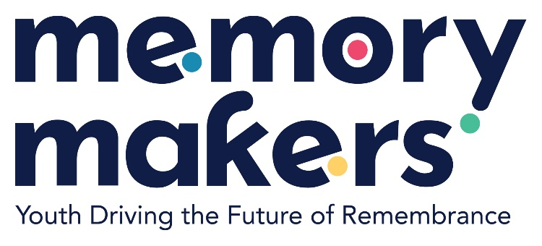

|  |  |
| --- | --- |
| **Location:** | Alytus/Lithuania |
| **Date:** | 16 May 2025 |

**VOICES OF TOLERANCE: YOUTH FORUM ON BELONGING EVENT REPORT**

|  |  |  |  |
| --- | --- | --- | --- |
| Female: | 56 | | |
| Male: | 46 | | |
| Non-binary: | 3 | | |
| From country 1 Lithuania: | 97 | | |
| From country 2 Ireland: | 3 | | |
| From country 3 United Kingdom: | 4 | | |
| From country 4 Poland: | 1 | | |
| Total number of participants: | 105 Participants | From total number of countries: | 4 Countries |

The *Voices of Tolerance: Youth Forum on Belonging* took place on May 16, 2025 in Alytus, Lithuania. This event was designed to foster critical historical awareness, promote diversity, and empower youth to counter discrimination in their communities. Hosted by AY Institute in cooperation with the Kaunas Ninth Fort Museum, the event created a safe and engaging space for students to reflect on the Holocaust, Roma experiences, and broader human rights issues.

**Objectives and Highlights**

The 4-hour forum gathered over 100 students and educators for a series of four interactive workshops:

● **“Rescuers of the World”** explored the stories of Lithuanian citizens who rescued Jews during the Holocaust.

● **“Romany Bacht”** introduced Roma history, traditions, and the discrimination faced by the Roma community in both historical and modern contexts.

● **“(Not) Childish Stories of the Ghetto”** presented personal stories of children who lived through the Holocaust, using diary excerpts and reflective dialogue.

● **“To Punish or to Forgive”** focused on ethical dilemmas around Holocaust perpetrators, encouraging participants to discuss justice, memory, and forgiveness.

**Outcomes**

Throughout the forum, experiential learning methods such as role-play guided discussion, and the use of authentic historical materials were used to strengthen emotional engagement and personal reflection. The activities emphasized moral courage, civic responsibility, and inclusion.

**Conclusion**

The event concluded with a collective reflection and idea-sharing session where participants proposed future youth-led initiatives aimed at strengthening tolerance and remembrance culture. As a WP2 activity under Memory Makers, this event contributes to the project’s wider goals of fostering inclusive societies, addressing antisemitism and anti-Roma discrimination, and encouraging young people to take an active role in shaping a respectful and just Europe.